Project Title: | Chennai Property Hub — A Cloud-Based SaaS Platform for Property Buying, Selling & Rental Management (Chennai Region)
Course: | Cloud Computing and Big Data Analytics
Student / Group Name: | Ch. Sri Lakshmi
Roll No. / Register No.: | 192311342
Faculty Name: | Dr.Hemavathi
Cloud Service Provider Used: | Amazon Web Services (AWS)
Date: | 02/09/2026

1. PROBLEM STATEMENT

The process of finding, buying, renting and managing properties is often fragmented across different platforms and manual communication methods. Customers may find it difficult to search for suitable properties based on location, property type, area and price range. Property owners and administrators also require a convenient system to manage property information and customer enquiries.

The proposed Chennai PropertyHub is a cloud-based Software as a Service (SaaS) application designed to simplify property buying and rental activities in Chennai. The system allows users to search and view properties based on transaction type, property type, locality and area. It also provides property details and supports property management and customer enquiry operations.

The application is developed using Python and Flask and is designed for deployment on a cloud platform so that users can access the system through a web browser without installing the application locally.

2. OBJECTIVE

The main objective of Chennai PropertyHub is to design and develop a cloud-based SaaS application for managing property buying and rental activities.

The specific objectives are:

To develop a web-based property management application using Python and Flask.

To provide property listings for buying and renting.

To allow users to search properties based on transaction type and property type.

To provide locality-based property searching.

To filter properties according to minimum and maximum area.

To display detailed information about individual properties.

To support residential and commercial properties.

To provide facilities for customer enquiries.

To maintain property information using a database.

To demonstrate deployment of the application on a cloud platform.

To demonstrate the Software as a Service (SaaS) model.

To maintain the source code using Git and GitHub.

3. REQUIREMENTS AND ENVIRONMENT USED

3.1 Hardware Requirements
Component | Requirement
Processor | Intel Core i3 or above
RAM | Minimum 4 GB
Storage | Minimum 2 GB free space
Internet | Required for cloud deployment and SaaS access
Display | Standard monitor

3.2 Software Requirements
Software / Tool | Purpose
Windows | Development environment
Visual Studio Code | Application development
Python | Backend programming
Flask | Web application framework
SQLite | Database management
HTML5 | Web page structure
CSS3 | User interface styling
JavaScript | Client-side interaction
Bootstrap | Responsive UI design
Git | Version control
GitHub | Source code repository
Microsoft Azure | Cloud deployment
Google Chrome | Application testing

3.3 Programming Technologies

The application uses Python with Flask for backend development. Flask handles routing, request processing and communication with the database.

HTML, CSS, Bootstrap and JavaScript are used for the frontend interface.

SQLite is used for storing property-related information during development and demonstration.

4. DESIGN / PROPOSED SOLUTION

4.1 Proposed System

The proposed system is a cloud-based property management platform that provides a centralized interface for property searching and management.

Users can access the system through a web browser and search for properties according to their requirements.

The application supports:

Property buying

Property renting

Residential properties

Commercial properties

Location/locality search

Area-based filtering

Property details

Property management

Customer enquiries

Rental agreement information

Cloud deployment

4.2 Major Modules

Module 1 – Home Page

The home page provides the main interface of the application.

Users can select:

Transaction type

Property type

Location/locality

Minimum area

Maximum area

The search button sends the selected criteria to the Flask backend.

Module 2 – Property Search

The property search module retrieves properties based on the selected filters.

The user can search using:

Buy / Rent

Residential / Commercial

Locality

Minimum area

Maximum area

The system displays only the properties matching the selected criteria.

Module 3 – Property Listing

The property listing page displays available properties as cards.

Each property card displays:

Property title

Transaction type

Property type

Locality

Area

Number of bedrooms

Price/rent

View Details option

Module 4 – Property Details

The property details page provides complete information about a selected property.

The information includes:

Property title

Location

Locality

Area

Property type

Bedrooms

Bathrooms

Price/rental value

Amenities

Description

Module 5 – Commercial Property Management

The system supports commercial properties such as:

Office spaces

Shops

Commercial buildings

Users can filter properties based on the commercial property type.

Module 6 – Customer Enquiry

The customer enquiry module allows interested customers to submit enquiries regarding a property.

The enquiry can contain:

Customer name

Phone number

Email

Property ID

Message

Module 7 – Rental Agreement

The application design includes rental agreement information such as:

Tenant name

Property

Monthly rent

Security deposit

Agreement start date

Agreement end date

5. SYSTEM ARCHITECTURE

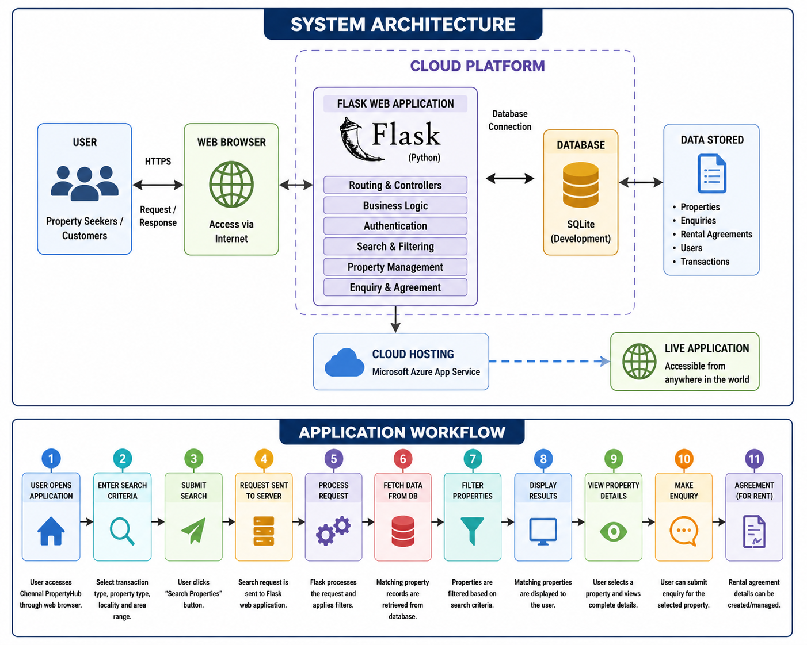

6. SOFTWARE AS A SERVICE MODEL

Chennai PropertyHub demonstrates the Software as a Service (SaaS) model.

In the SaaS model, users do not need to install the complete application on their computers. The application is hosted on a cloud platform and accessed through the Internet.

SaaS characteristics demonstrated:

Browser-based access.

Centralized application.

Cloud deployment.

No requirement for users to install Python or Flask.

Centralized property information.

Easy access from different devices.

Application maintenance can be performed centrally.

The system therefore demonstrates how a property management application can be delivered as a cloud service.

7. DATABASE DESIGN

The application uses a database for storing property and transaction-related information.

Property Table
Field | Description
ID | Unique property identifier
Title | Property name/title
Property Type | Residential/Commercial
Transaction Type | Buy/Rent
Location | City
Locality | Specific area
Area | Property area in sq.ft
Price | Property purchase price/rental value
Bedrooms | Number of bedrooms
Bathrooms | Number of bathrooms
Amenities | Available facilities
Description | Property description

Enquiry Table
Field | Description
ID | Unique enquiry ID
Customer Name | Name of customer
Phone | Customer phone
Email | Customer email
Property ID | Related property
Message | Customer enquiry

Agreement Table
Field | Description
ID | Agreement ID
Property ID | Related property
Tenant Name | Tenant name
Monthly Rent | Monthly rental amount
Deposit | Security deposit
Start Date | Agreement beginning

8. SAMPLE PROPERTY DATA

The application contains sample Chennai property data for demonstration and testing.
Property | Type | Transaction | Locality | Area | Price/Rent
Modern 2 BHK Apartment | Residential | Rent | Velachery | 1200 sq.ft | ₹25,000/month
Luxury Villa | Residential | Buy | OMR | 1800 sq.ft | ₹95 Lakhs
3 BHK Family Apartment | Residential | Buy | Tambaram | 1500 sq.ft | ₹72 Lakhs
Premium Office Space | Commercial | Rent | Guindy | 2500 sq.ft | ₹75,000/month
Commercial Shop | Commercial | Buy | T. Nagar | 900 sq.ft | ₹1.2 Crore
Sea View Apartment | Residential | Rent | Adyar | 1400 sq.ft | ₹35,000/month
Independent Villa | Residential | Rent | Anna Nagar | 2200 sq.ft | ₹60,000/month
Residential Plot | Residential | Buy | Sholinganallur | 2400 sq.ft | ₹1.1 Crore

9. ALGORITHM / PSEUDOCODE

9.1 Property Search Algorithm

START

Open Chennai PropertyHub

Display search form

Read transaction type

Read property type

Read locality

Read minimum area

Read maximum area

Send search criteria to Flask backend

Retrieve property records

FOR each property

Check transaction type

IF transaction matches

Continue

ELSE

Exclude property

Check property type

IF property type matches

Continue

ELSE

Exclude property

Check locality

IF locality matches

Continue

ELSE

Exclude property

Check minimum and maximum area

IF area is within range

Include property

ELSE

Exclude property

END FOR

Display matching properties

IF no property is found

Display "No properties found"

END IF

STOP

10. APPLICATION WORKFLOW



11. IMPLEMENTATION / SOURCE CODE

11.1 Flask Application

The backend is implemented using Python Flask.

The application creates routes for the home page, property search and property details.

Example:

from flask import Flask, render_template, request

app = Flask(__name__)

@app.route("/")

def home():

return render_template("index.html")

@app.route("/properties")

def property_list():

transaction = request.args.get("transaction", "")

property_type = request.args.get("property_type", "")

locality = request.args.get("locality", "")

# Property filtering logic

return render_template(

"properties.html",

properties=results

)

if __name__ == "__main__":

app.run(debug=True)

12. MODERN TOOLS USED
Tool | Application in Project
Python | Backend programming
Flask | Web application development
HTML5 | Frontend structure
CSS3 | Styling
Bootstrap | Responsive interface
JavaScript | Client-side interaction
SQLite | Database
Visual Studio Code | Development environment
Git | Version control
GitHub | Source code management
Microsoft Azure | Cloud deployment
Google Chrome | Testing and demonstration

13. CLOUD DEPLOYMENT

The application is designed as a cloud-based SaaS application.

The Flask application can be deployed using Microsoft Azure App Service.

Deployment architecture:

Local Development

|

v

Visual Studio Code

|

v

Git Repository

|

v

GitHub

|

v

Microsoft Azure App Service

|

v

Cloud Hosted Web Application

|

v

Internet Users

Azure App Service provides a managed hosting environment for Python web applications, allowing the Flask application to be accessed through a public web address.

14. GITHUB INTEGRATION

Git is used for version control and GitHub is used to maintain the project source code.

The project repository contains:

chennai-propertyhub/

│

├── app.py

├── requirements.txt

│

├── templates/

│ ├── index.html

│ ├── properties.html

│ └── property.html

│

├── static/

│ └── style.css

│

├── ml/

│

├── matlab/

│

└── tests/

Git commands used:

git init

git add .

git commit -m "Initial Chennai PropertyHub application"

git branch -M main

git push -u origin main

15. TEST CASES AND EXPECTED / ACTUAL RESULTS
Test Case | Test Condition | Expected Result | Actual Result | Status
TC01 | Open application | Home page should load | Home page loaded | PASS
TC02 | Select Buy | Buy properties should be filtered | Buy properties displayed | PASS
TC03 | Select Rent | Rental properties should be displayed | Rental properties displayed | PASS
TC04 | Select Residential | Residential properties should be displayed | Residential properties displayed | PASS
TC05 | Select Commercial | Commercial properties should be displayed | Commercial properties displayed | PASS
TC06 | Search Velachery | Velachery properties should appear | Velachery property displayed | PASS
TC07 | Enter area range | Matching area properties should appear | Matching properties displayed | PASS
TC08 | View property details | Complete property information should appear | Property details displayed | PASS
TC09 | Invalid locality | No matching property message should appear | No properties found | PASS
TC10 | Open cloud deployment | Hosted application should load | Application loaded | PASS

16. EXECUTION AND OUTPUT

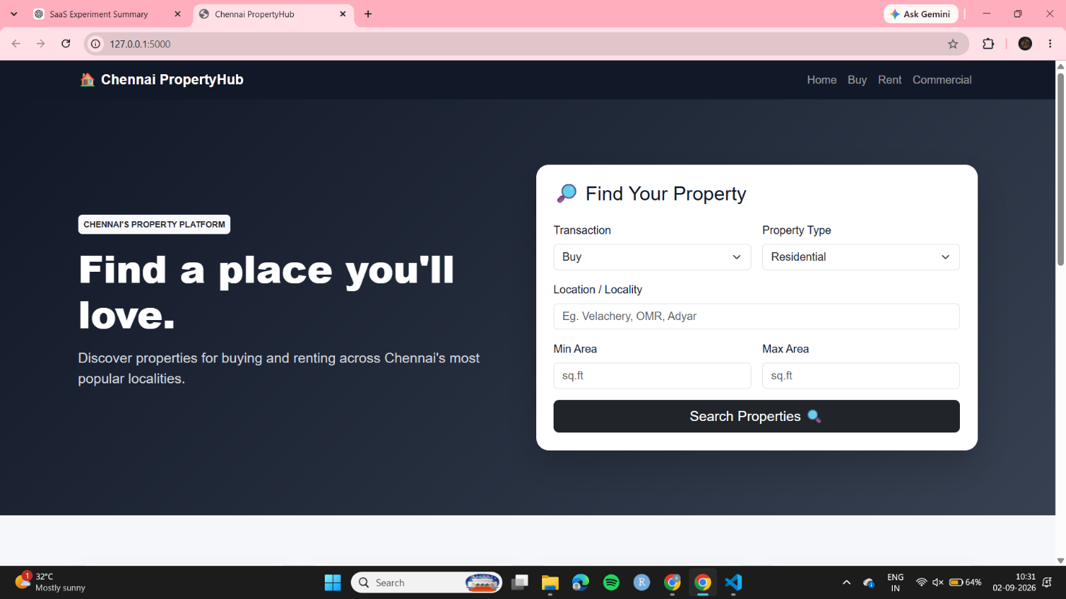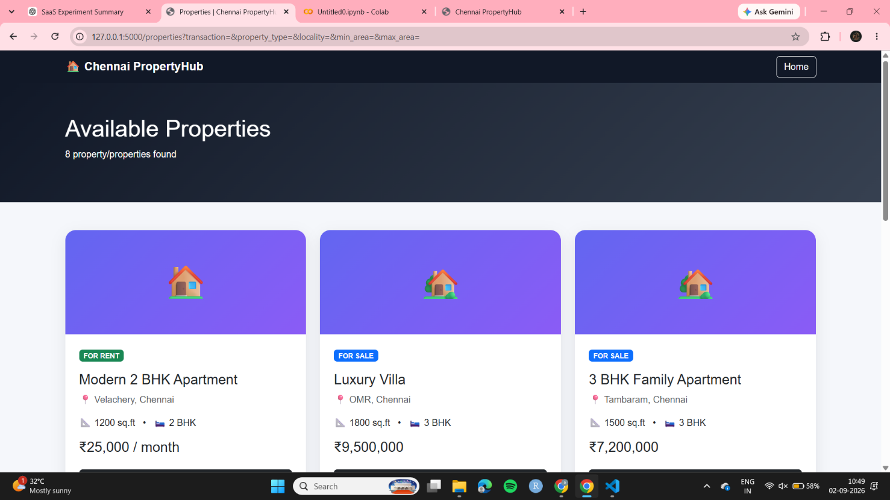

18. ANALYSIS AND DISCUSSION

The developed application demonstrates how cloud computing can be applied to a real-world property management problem.

A traditional property management system may require users to install software locally and maintain separate copies of property data. In the proposed SaaS system, the application can be centrally hosted and accessed through a web browser.

The use of Flask provides a lightweight backend framework for handling web requests and application logic. SQLite provides a simple database solution for development and demonstration.

The cloud deployment model provides better accessibility because users can access the application remotely.

Advantages

Easy browser-based access.

Centralized property information.

Reduced local installation requirements.

Search and filtering functionality.

Support for residential and commercial properties.

Easy maintenance and updating.

Cloud accessibility.

GitHub-based source code management.

Responsive user interface.

Scalable architecture for future development.

19. ENGINEERING DECISIONS

Why Python?

Python was selected because it is easy to develop, widely used and provides extensive support for web application development.

Why Flask?

Flask was selected because it is lightweight and suitable for developing a small-to-medium web application. It provides routing, request handling and integration with databases.

Why SQLite?

SQLite was selected for the development stage because it is lightweight, requires minimal configuration and is suitable for demonstration and testing.

Why GitHub?

GitHub provides centralized source-code storage, version control and collaboration capabilities.

Why Azure?

Microsoft Azure provides cloud infrastructure and managed application hosting. Azure App Service supports deployment of Python web applications and is suitable for demonstrating the SaaS model.

20. SECURITY CONSIDERATIONS

Security is important for a property management application because the system can handle customer and property information.

The following security mechanisms can be incorporated:

Input validation.

Secure database queries.

Authentication for administrative functions.

Authorization for property management.

HTTPS for cloud communication.

Secure handling of customer information.

Environment variables for sensitive configuration.

Restricted database access.

Regular source-code updates.

Cloud access control.

For a production version, additional security mechanisms such as role-based access control, encrypted databases, secure authentication and cloud monitoring should be implemented.

21. BROADER CONSIDERATIONS

Privacy

Customer contact details should be protected and accessed only by authorized users.

Accessibility

The web interface should be responsive so that users can access it using different screen sizes.

Economic Consideration

Cloud deployment reduces the need for maintaining dedicated physical servers. Cloud resources can be scaled according to application requirements.

Sustainability

Cloud infrastructure can reduce the requirement for individual organizations to maintain their own physical servers.

Professional Responsibility

Property information should be accurate and regularly updated. The system should avoid displaying misleading property information.

22. LIMITATIONS

The current prototype has some limitations:

The initial development database uses SQLite.

Authentication and role-based access can be enhanced.

Online payment functionality is not implemented.

Property image upload can be added in future.

Advanced recommendation functionality can be added.

Real-time property availability can be implemented in future.

Production deployment should use a managed cloud database rather than a local SQLite file.

Advanced security mechanisms can be added for a production environment.

23. FUTURE ENHANCEMENTS

The application can be extended with:

User registration and login.

Property owner accounts.

Administrator dashboard.

Property image uploads.

Google Maps integration.

Online payment.

Digital rental agreement generation.

Email/SMS notifications.

Advanced property recommendations.

Cloud database such as Azure PostgreSQL.

Property comparison.

Saved/favourite properties.

Real-time notifications.

Advanced analytics dashboard.

Mobile application.

24. CONCLUSION

The Chennai PropertyHub project successfully demonstrates the design and development of a cloud-based property buying and rental management application.

The system provides a centralized platform for searching and viewing residential and commercial properties. Users can filter properties according to transaction type, property type, locality and area.

Python and Flask were used to implement the backend, while HTML, CSS, Bootstrap and JavaScript were used for the frontend. SQLite was used for database management during development. Git and GitHub were used for source-code management, and Microsoft Azure was used to demonstrate cloud deployment.

The project demonstrates the Software as a Service (SaaS) concept because the application can be hosted in the cloud and accessed through a web browser without requiring users to install the complete application locally.

The implemented system provides a foundation that can be extended with authentication, cloud databases, payment systems, maps, analytics and intelligent property recommendation features.

